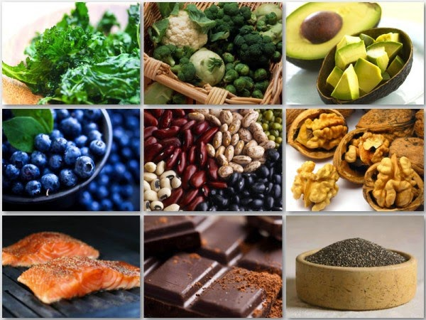  HOPE. What you eat Matters!  5 Superfoods for Cancer Patients  - Garlic & Onions: high antibacterial properties for blocking cancer-causing substances, as well as enhanced DNA repair  - Dark Leafy Greens: high amount of phytochemical carotenoids, shown to inhibit cancer growth  - Ginger: anti-inflammatory properties and anti-spasmodic effects in the gut.  - Pomegranate Juice: help inhibit cancer cells from multiplying, but there is some evidence that it can also help decrease the spread of carcinogenic cells.  - Turmeric: prevention and treatment of various types of cancer.
  Be Healthy.
  Diet & Lifestyle
  People with Cancer Have Different Diet Needs People with cancer often need to follow diets that are different from what you think of as healthy.
  You need to eat to keep up your strength to deal with the side effects of treatment.
  Eat plenty of protein and calories when you can. This helps you keep up your strength and helps rebuild tissues harmed by cancer treatment.
  Drink plenty of liquids. It is even more important to get plenty to drink on days when you cannot eat.
  The Cancer Support Community www.cancersupportcommunity.org
  Contact Us
  Phone: (904) 278-5462
  Email: Email
  Web: Web address
   | ardnas health care services  2105 Park Ave Ste 25  Orange Park, FL 32073
  
  
  ardnas health care services
    - “I believe in the greatest gift you can give your family and the world is a HEALTHY YOU!” ~Joyce Meyer
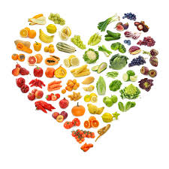  Lifestyle Changes Health & Wellness  Green Cleanse Recipe  Smoothie Recipe  - Apples  - Celery  - Lettuce  - Cucumber  - Lime  - Ginger  Juice all the ingredients and drink daily! | Alkaline Diet  Following an alkaline diet means choosing fruits and vegetables over higher-calorie, higher-fat choices.  Some studies have found that an alkaline environment may make certain chemotherapy drugs more effective or less toxic.  What can you eat?  Most fruits and vegetables, soybeans and tofu, and some nuts, seeds, and legumes are alkaline-promoting foods, so they are fair game.  Dairy, eggs, meat, most grains, and processed foods, like canned and packaged snacks and convenience foods, fall on the acid side and are not allowed.  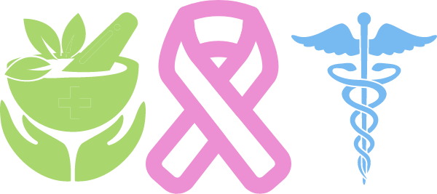 | 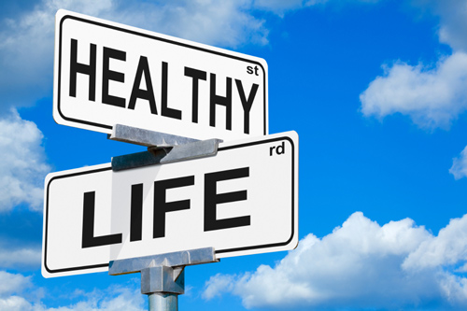  How GMO’s affect your health  - GMO foods can present significant allergy risks to people.  - GMO’s create antibiotic-resistant bacteria can resist antibiotics, making them hard to kill.  - Can cause infertility  - Birth defects  - Cancer  - Gluten disorders  “The food you eat can be either the safest and most powerful form of medicine or the slowest form of poison.” Ann Wigmore

